**LEARN UMRAH IN VR**

**Jameel Ahmed**

**Ahsan Shafiq Khan**



**Department of Computer Science**

**COMSATS UNIVERSITY ISLAMABAD**

**ATTOCK CAMPUS-PAKISTAN**

SESSION 2017-2021

**LEARN UMRAH IN VR**

*Undertaken By:*

**JAMEEL AHMED**

CIIT/FA17-BCS-012/ATK

**AHSAN SHAFIQ KHAN**

CIIT/FA17-BCS-034/ATK

*Supervised By:*

**SIR SHEZAD RIZWAN**

A DISSERTATION SUBMITTED AS A PARTIAL FULFILLMENT OF THE REQUIREMENTS FOR THE DEGREE OF BACHELOR OF SCIENCE IN SOFTWARE ENGINEERING

**Department of Computer Science**

**COMSATS UNIVERSITY ISLAMABAD**

**ATTOCK CAMPUS-PAKISTAN**

SESSION 2017-2021

|  |  |
| --- | --- |
| Title | Learn Umrah VR |

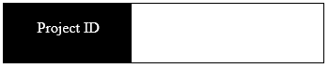

|  |  |  |
| --- | --- | --- |
| **Supervisor Name** | Mr.Shezad Rizwan | |
| **Members Name** | **Reg No.** | **Email Address** |
| Jameel Ahmed | CUI/FA17-BCS-012/ATK | [Mr.SalmanKhanLecturer@gmail.com](mailto:Mr.SalmanKhanLecturer@gmail.com) |
| Ahsan Shafiq Khan | CUI/FA17-BCS-034/ATK | rx82050@gmail.com |

**CHECKLIST:**

Number of Pages in this report

I/We have enclosed the soft-copy of this document along-with the

code and scripts created by myself.



My/Our supervisor has attested to the attached document

I/We confirm to state that this project is free from any type of plagiarism

and misuse of the copyrighted material.

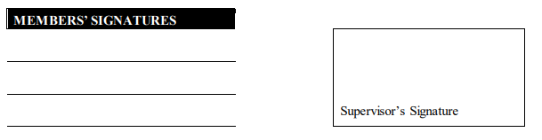

This work, entitled **“Learn Umrah In VR”** has been approved for the award

of

**Bachelors of Science in Computer Science**

Date

**External Examiner:**

**Head of Department:**

**Chair Person:**

**Department of Computer Science**

**COMSATS UNIVERSITY ISLAMABAD**

**ATTOCK-PAKISTAN**

**UNDERTAKEN**

We certify that this is my/our own work. The work has not, in whole or in part, been presented elsewhere for assessment. Where material has been used from other sources it has been properly acknowledged. If this statement is untrue, we acknowledge that we will have committed an assessment offence and shall be liable to punishable action under the plagiarism rules of HEC.

______________ ____________________

JAMEEL AHMED AHSAN SHAFIQ KHAN

FA17-BCS-012 FA17-BCS-034

**Acknowledgments**

In the name of Allah, Most Gracious, Most Merciful. First, we would like to thank our parents and teachers who helped us financially and morally at all times. We would also like to thank Mr. Shezad Rizwan for guiding us to work hard. We found it very helpful to discuss our plan. His critical comments on our work have made us think of new ideas. We are thankful to Allah Almighty who gave us all the resources to make this project for the benefit of mankind.

**ABSTRACT**

We have studied that the people faced so many troubles while learning about umrah from different academies. so, in this project we have made a virtual reality that will help user to learn all the procedure of umrah step by step virtually and clearer than academies. User will get more and more better learning process of umrah through this app.

**Table of Contents**

**CHAPTER 1** 1

**INTRODUCTION** 1

**1.1** **Introduction:** 2

**1.2** **Control:** 2

**1.2.1 Achievements:** 2

**1.2.2 3D model of masjid-e-haram and safa-o-marwa hills:** 2

**1.3 Application strategy:** 3

**1.4 Virtual Reality Interface:** 3

**1.4.1 User movement:** 3

**1.4.2 Sections:** 3

**1.5 Actions:** 4

**1.5.1 Movement:** 4

**1.5.2 User actions:** 4

**1.6 Objectives:** 4

**1.7 Scope** 4

**1.8 Problem Statements:** 5

**CHAPTER 2** 6

**Literature Review** 6

**2.1 Literature Review:** 7

**2.2 Competitors:** 7

**2.2.1 First Person Shoot:** 7

**CHAPTER 3** 8

**REQUIREMENTS SPECIFICATION** 8

**3.1 Requirement Specifications:** 9

**3.1.1 Functional Requirements:** 9

**3.1.2 Non-Functional Requirements:** 10

**CHAPTER 4** 12

**PROJECT DESIGN** 12

**4.Methodology:** 13

**4.1 Activity Diagram:** 13

**4.1.1 Activity Diagram:** 13

**4.1.2 Activity Diagram:** 14

**4.2 Use Case Diagram:** 15

**4.2.1 Use Case Diagram:** 16

**4.2.2 Use Case Diagram:** 17

**4.3 Sequence diagram:** 18

**4.3.1 Sequence diagram:** 18

**4.3.2 Sequence diagram:** 19

**4.4 Context Diagram:** 20

**4.5 Conclusion:** 20

**CHAPTER 5** 21

**Implementations** 21

**5.1 App Development Stages:** 22

**5.1.1 App Story** 22

**5.1.2 Designing Software Selection** 22

**5.1.3 Designing Game Environment:** 22

**5.1.4 Converting 3D App into Virtual Reality:** 22

**5.1.5 Choosing Game Development Engine:** 23

**5.1.6 Choosing VR Platform:** 24

**5.2 IDEs** 24

**5.2.1 Visual Studio:** 24

**5.3 Designing Tools** 24

**5.3.1 Unity Hub:** 24

**5.4 User Interface** 24

**5.4.1 Login Panel** 25

**5.4.2 Splash Screen** 26

**5.4.3 Main Menu** 27

**5.4.4 Ihram steps** 28

**5.4.5 Tawaf e Kaba** 29

**5.4.6 Hajre aswad** 30

**5.4.7 Safa o Marwa Hills** 31

**5.4.8 Safa o Marwa Track** 32

**5.4.9 Sacred Places Information** 33

**CHAPTER 6** 34

**Evaluation** 34

**6.1 Evaluation:** 35

**6.1.1 Unit Testing** 35

**6.2.2 Integration Testing** 36

**6.3.3 Function Testing:** 37

**CHAPTER 7** 39

**Conclusion and Future Work** 39

**7.1 Conclusions** 40

**List of Figures**

|  |  |  |
| --- | --- | --- |
| **Figure No** | **Figure Title** | **Page number** |
| **4.1.1** | Activity diagram of account creation | 14 |
| **4.1.2** | Activity diagram of main menu | 15 |
| **4.2.1** | Use case diagram of account creation | 16 |
| **4.2.2** | Use case diagram of main menu | 17 |
| **4.3.1** | Sequence diagram of account creation | 18 |
| **4.3.2** | Sequence diagram of main menu | 19 |
| **4.4.1** | Context Diagram | 20 |
| **5.4.1** | Login Panel | 25 |
| **5.4.2** | Splash screen | 26 |
| **5.4.3** | Mian menu | 27 |
| **5.4.4** | Ihram steps | 28 |
| **5.4.5** | Learning module | 29 |
| **5.4.6** | Hajre aswad | 30 |
| **5.4.7** | Safa o marwa hills | 31 |
| **5.4.8** | Safa o marwa track | 32 |
| **5.4.9** | Sacred places information | 33 |

**List of Tables**

|  |  |  |
| --- | --- | --- |
| **Table No** | **Table Description** | **Page No** |
| **3.1** | Display | 9 |
| **3.2** | Development Tools | 9 |
| **3.3** | The Controls | 10 |
| **3.4** | Operating System Controls | 10 |
| **3.5** | User Interface | 10 |
| **3.6** | Quality Graphics | 11 |
| **3.7** | Performance | 11 |
| **6.1** | Testing player | 35 |
| **6.2** | Player learning umrah | 36 |
| **6.3** | Player performing umrah | 36 |
| **6.4** | Update score | 37 |
| **6.5** | User Interface | 37 |
| **6.6** | Sound testing | 38 |

# **CHAPTER 1**

# **INTRODUCTION**

## **Introduction:**

The Information and computer Technology (ICT) incorporate almost all aspects of life, including education and all other learning process. The current method of learning about Umrah rituals are from different academies, YouTube, text books and from different virtual apps which shows only the steps that poses difficulties for users in learning. To address such problems, this project proposes the use of virtual reality (VR) to aid in learning about all the rituals. This type of learning can help Users use both text media and 3D models, thus helping them gain a better understanding in learning Umrah process.

## **Control:**

The player experiences the masjid-e-haram environment that is presented in the model, through a first-person view of the scene, the person can move in the masjid haram and feel the environment.

The app is organized in different sections that correspond to the different challenges in the umrah performance. The user progresses in the app by each requirement of umrah and move to the next section. Each section has its objectives.

### **1.2.1 Achievements:**

The user advances in the application by finishing each section and get the next objective of umrah performing. Each section has its tasks. A set of objectives are given in every section. After completion of objectives of corresponding section user will move to the next section having different objectives of umrah performing. After completion of all objectives the score of the user will be assigned as the result.

### **1.2.2 3D model of masjid-e-haram and safa-o-marwa hills:**

The whole application revolves around the 3d model of masjid-e-haram and safa-o-marwa hills, our models are designed in the blender tool. It has textures and colors and different materials are used to design the model of masjid-e-haram and safa-o-marwa hills.

## 

## **1.3 Application strategy:**

This application is designed to teach the people about performing umrah, as we know that there is too much difficult for the elder people for visiting the coaching centers and taking classes about umrah performing and its faraiz. we are developing a such an app that will be helpful to the all of our users so they can learn at home easily.

## **1.4 Virtual Reality Interface:**

The user experiences the masjid-e-haram in virtual reality. The game interface provides dominant visuals and audios like takbeerat and duas which is appealing for the user.

### **1.4.1 User movement:**

The user can freely move in the masjid Haram when he want to visit, he can also move in safa & marwa.

### **1.4.2 Sections:**

Sections are the main part of our application there are main five sections and some of them are sub divided in to sections. Different sections have their different objective.

#### **Learning umrah:**

The user will get option about learning umrah according to their gender. This section will teach the user to how to perform umrah it will teach all of the four main faraiz of umrah.

#### **Performing umrah:**

This section will allow the user to perform umrah in the 3d model of masjid-e-haram and safa-o-marwa hills. This section will calculate the user score on the completion of all objectives and score will be displayed at the end on the basis of your performance.

#### **Virtual tour:**

This section will give the two options to the user to whether he wants to take virtual tour of masjid-e-haram or safa-o-marwa hills. This section will allow the user to move freely around the models.

#### **Dua’s and kalimat:**

This section contains all of the duas and kalimat that are recited by pilgrims during umrah.

## **1.5 Actions:**

Actions are the things done by the player, its movement,

### **1.5.1 Movement:**

Players can move anywhere in the model, enter into the masjid-e-haram, safa-o-marwa. The Player is moving left, right, forward, and backward anywhere he like with the help of a joystick.

### **1.5.2 User actions:**

The user will move around the khaana-e-kaabah to perform tawaf user will have to make seven rounds around khaana-e-kaabah to complete tawaf in anti-clockwise direction. User will also make seven rounds between safa-o-marwa hills to perform sahii.

## **1.6 Objectives:**

* To teach all the steps of Umrah.
* To perform the Umrah in a right manner.
* To teach kalima’s that will be recited during the performing Umrah in haram sharif.
* To remove the difficulties of old agers they face to reach tuition center to attend the classes and learn the Umrah steps.

## **1.7 Scope**

Our project Scope includes the following:

* People will learn the method of Umrah as if they are actually doing it.
* It will be easy for the people to learn all the steps of Umrah without going to tuition center and attend the classes.
* The main purpose is less time-consumption for people to learn and this issue resolve by this system as it performs Analytic process quickly.

## **1.8 Problem Statements:**

* Although there are some applications displaying the descriptions about the sacred places of Kaaba but there is no proper application which provide learners proper 3D view without using augmented reality.
* Mostly the old people face troubles while going to academies for learning Umrah process and face difficulties to get reaching in academies.
* Time consuming need a lot of time to go and attend the classes.
* Inability to keep attention during the classes.

**1.9 Proposed Solution:**

In this system we are providing a single platform which allows learners to understand complete information using virtual reality along with voice and descriptions.

# **CHAPTER 2**

# **Literature Review**

## **2.1 Literature Review:**

A literature review paper is a type of academic paper, in which it includes information of fundamental findings, also include working and theoretical contribution of a relevant topic. Virtual reality is the reality trending in today's world since 2014 and still not at the mature stage. Virtual Reality provides interaction of players to the game world in an almost real way by doing physical activity you interact with virtual game play. Studying things in Virtual reality is one of the latest achievements of technology.

By determining all the needs and researching needs we came through Unity 3D a free easiest way to develop gamming applications.

## **2.2 Competitors:**

The rapid penetration of advanced technology into every aspect of society, how, when, and where we operate, how individuals and companies manage themselves, and the game to complement other development companies. How our game should be structured is undergoing significant change. Continuing and developing similar games will not do us any good in completing them.

### **2.2.1 First Person Shoot:**

The FPS is a popular VR based game in which the environment is provided in such a way that the player will need to divert his full attention towards the environment. The user will be able to experience the most extreme environments by interacting with some steps which are usually performed in Umrah.

# **CHAPTER 3**

# **REQUIREMENTS SPECIFICATION**

## **3.1 Requirement Specifications:**

In this chapter, we’ve all the functional and Non-Functional requirements of our application.

### **3.1.1 Functional Requirements:**

The Functional Requirement of any system can be related to both hardware and software in terms of specific functionality which can define what can a specific system able to accomplish. A functional requirement is in the form of a professional document which explains the desired output when the system is deployed in certain kinds of environment. In our project there are four Functional requirements:

1. wear Ihram
2. Tawaf
3. Sahi
4. Balding

#### **3.1.1.1 Display**:

|  |  |
| --- | --- |
| **FR-NO** | FR-01-01 |
| **FR-Name** | Display |
| **Summary** | The app must be played in Android Mobiles and the User has the options to play in full-screen size. |

**Table 3.1 Display**

#### **3.1.1.2 Development Tools:**

|  |  |
| --- | --- |
| **FR-NO** | FR-01-02 |
| **FR-Name** | Development Tools |
| **Summary** | App is implemented in C# scripts and developed in Unity 3D engine |

**Table 3.2 Development Tools**

#### **3.1.1.3 The Controls:**

|  |  |
| --- | --- |
| **FR-NO** | FR-01-03 |
| **FR-Name** | Control |
| **Summary** | It must be controlled with VR oculus and Joy Stick. |

**Table 3.3 The Controls**

#### **3.1.1.4 Operating System Control:**

|  |  |
| --- | --- |
| **FR-NO** | FR-01-04 |
| **FR-Name** | Android |
| **Summary** | This app must be played on Android OS and compatible with VR devices. |

**Table 3.4 Operating system Controls**

### **3.1.2 Non-Functional Requirements:**

The Non-Functional requirements describe the characteristics of the system it describes how a system performs and behaves based on limits of functionality. Also defines the limits on different functionalities are. For example, response time, system validation, etc.

#### **3.1.2.1 User Interface:**

|  |  |
| --- | --- |
| **NFR-NO** | NFR-01-01 |
| **NFR-Name** | User Interface |
| **Summary** | User interface Should be clean and compatible with mobile screens and UI must be controlled through Gear VR. |

**Table 3.5 User Interface**

#### **3.1.2.2 Quality Graphics:**

|  |  |
| --- | --- |
| **NFR-NO** | NFR-01-02 |
| **NFR-Name** | Safety Quality Graphics |
| **Summary** | This app must have high-end 3D Graphics. |

**Table 3.6 Quality Graphics**

#### **3.1.2.3 Performance:**

|  |  |
| --- | --- |
| **NFR-NO** | NFR-01-03 |
| **NFR-Name** | **Performance** |
| **Summary** | The primary performance requirements are the speed of the play. It must be with good FPS on system to have more reality |

**Table 3.7 User Interface**

# **CHAPTER 4**

# **PROJECT DESIGN**

## **4.Methodology:**

In this system we'll use incremental method which allows us to modify or add-up modules or functionalities as per demand/requirement.

Incremental phases:

* 1. Requirement gathering
  2. Design

## **4.1 Activity Diagram:**

In this array we are showing a graphical representation of the workflow of phased activities. This diagram shows the overall flow control. Activity diagrams can be formed with a small number. Here are the key shapes

* Arrows show the order of activities in which they are happening.
* Start represented with black circle.
* Action represented with rounded rectangle.
* End is represented with encircled black circle.

### **4.1.1 Activity Diagram:**

When user open the app, he will get two options sign up and sign in if the user already created his account then user will direct select the sign in option. After sign in the main menu will be open.

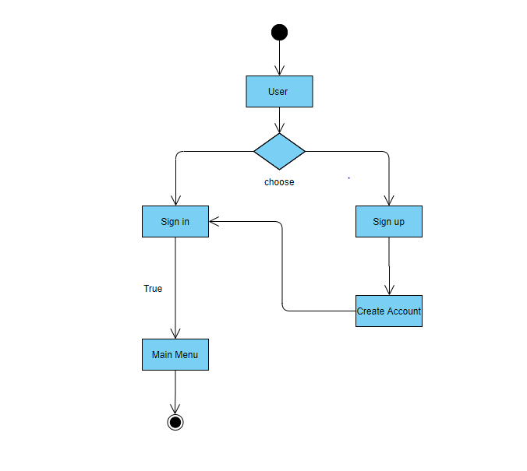  
**FIGURE 4.1.1 Acitivity Diagram of Account Creation**

### **4.1.2 Activity Diagram:**

When the main menu page will be opened the user will get further four options Learn Umrah, perform Umrah, Virtual Tour and Sacred places. To perform all the steps of umrah further there are 4 steps of umrah which the user will be perform and that’s are wear ihram doing tawaf around the Kaaba after this user will do sahi and the last step is balding.

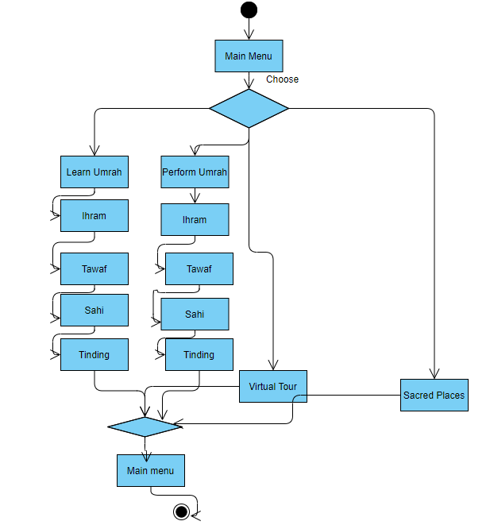  
**FIGURE 4.1.2 Acitivity Diagram of Main Menu**

## **4.2 Use Case Diagram:**

The use case diagram is used to briefly discuss the need for the system. This includes actions taken by actors, systems, users and specific actors. This method is used for system analysis and helps identify, define and organize system requirements. There is only one actor in our application and that is user.

**Components of use case:**

* Use case defines the relationship among and between the actors.
* The threshold is used to identify system actors, system users.

### **4.2.1 Use Case Diagram:**

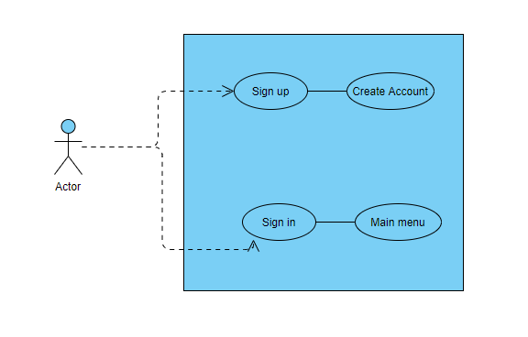

**FIGURE 4.2.1 Use Case Diagram of Account Creation**

User will get two options sign up and sign in when the user created his account then the account will be created after signing in the main menu page will be opened.

### **4.2.2 Use Case Diagram:**

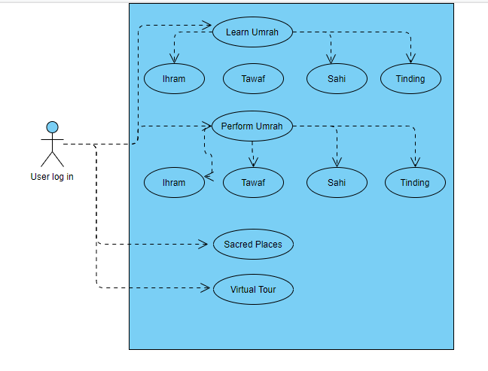

**FIGURE 4.2.2 Use Case Diagram of Main Menu**

After login the user will be display four options which is shown in above diagram when the user wants to perform umrah he will select the option (Perform Umrah) then further there are 4 steps of umrah. When the user want to learn umrah then he will select the (Learn Umrah) option further there are also four steps that how to learn Umrah.

## **4.3 Sequence diagram:**

A sequence diagram is defined in the software system configuration. It is represented by parallel lines that represent events and horizontal lines at the beginning and end that represent the system and the user.

### **4.3.1 Sequence diagram:**

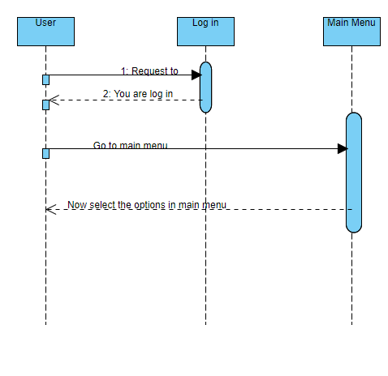

**FIGURE 4.3.1 Sequence Diagram of Account Creation**

Initially Users will register/login themselves. If the user details are valid according to database, then his account will be opened. Users see their information which we put in our app. When the user login then he will get the main menu page.

### **4.3.2 Sequence diagram:**

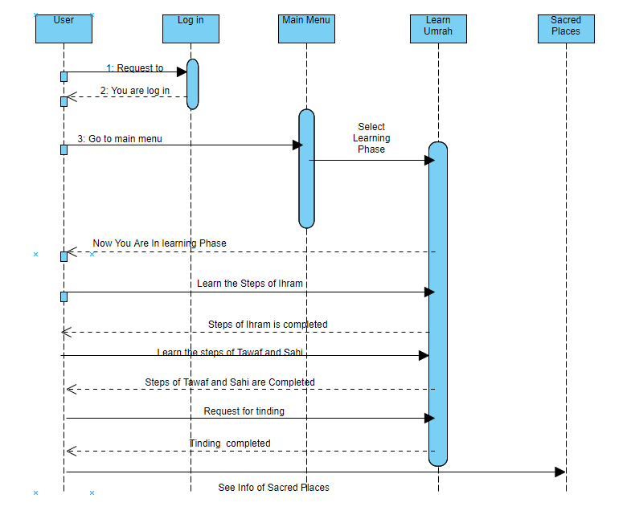

**FIGURE 4.3.2 Sequence Diagram of Account Creation**

After opening the main menu page the four options will be shown.When the user want to learn umrah he will select the learn umrah option. In learning umrah there are further few steps he will learn how to wear the Ihram after this he will start the tawaf around the Kaaba after completing the 7-circle user will move in Safa Marwa mountains after finishing sahi then user will bald then the learning process of umrah will be completed.Same process will be followed in performing option.But in performing the user will gain the marks.

## **4.4 Context Diagram:**

User

Unity Engine

Play Load menu

Select option Option load

Perform Score

Completed

**FIGURE 4.4.1 Context Diagram**

The user starts the playing by clicking the icon and the unity engine load the main menu to the user. User select stage, Unity Engine load the stage. The VR umrah will display shows the challenge to the user required to complete the all steps of umrah. The user starts to perform and complete the challenge. The unity engine displays Achievement on the screen and shows to performing umrah.

## **4.5 Conclusion:**

In this chapter we discuss all project designs including activity diagram, context diagram, use case diagram and continuity diagram. All these diagrams illustrate the design of our project which we discuss in this chapter. The activity diagram shows a step-by-step description of the activities. The sequence diagram describes the system sequentially. Using the case diagram shows the requirements of the system. The context diagram shows the initial level of the system.

# **CHAPTER 5**

# **Implementations**

## **5.1 App Development Stages:**

Following are the incremental phases to develop the full app.

### **5.1.1 App Story**

Here is how we designed our application Story.

Our application is all about the virtual reality. This is a learning app for the people who want to learn the procedures of Umrah from the very basics. When the user register his/herself in the app, they will be able to learn and performing umrah. The functional phases of this app are the learning and performing umrah. The first phase will be the learning phase and the second will be performing. Users will initially learn the procedures of umrah if they do not know anything about umrah, after that they can perform the umrah virtually and they will also be given marks according to their performance. If users know how to perform umrah, they can directly perform it easily. In learning phase users will be guided with each step by the chat bar on the screen but in performing it will be like a quiz that how better you are doing it and there will be no guidance of steps.

### **5.1.2 Designing Software Selection**

Following are the tools which are used to design the different components of the app.

* Blender 3D.
* Unity 3D Engine.
* Visual studio.
* Adobe photoshop.
* Illustrators(UIUX).

### **5.1.3 Designing Game Environment:**

We designed all our models in Blender 3D and in other designing softwares. After the completion of modelling, we applied texturing on them for better look.

### **5.1.4 Converting 3D App into Virtual Reality:**

After the completion of 3D app, it will be converted into virtual reality(VR) based by configuring the SDK with unity.

### **5.1.5 Choosing Game Development Engine:**

We had 3 options for game development engine

1. Unreal Engine

2. Unity3D

3. Game Maker Studio

We choose Unity 3D due to its easy interface and most popular and easy to develop Mobile games. Unreal engine and Game Maker studio are used to develop desktop games mostly. Unity is a cross platform development engine, everything is built in as compare to other engines like unreal engine etc.

**Features:**

**General:**

* It supports programming languages JavaScript and C# etc.
* It has good graphics.
* 64-bit editor.
* Action-Packed Physics

**Graphics:**

* 3D Graphics.
* Editable textures.
* High quality graphics.
* Low level rendering access.

**VR/AR support:**

It supports development for the following platforms:

* Google Cardboard.
* HTC VIVE.
* Oculus /VR

### **5.1.6 Choosing VR Platform:**

We choose Oculus /VR sets because of its very low cast and easy VR platform. VR Sets can be bought just in $20. Also Google provides very best APIs for unity that we don’t have to make much effort to develop our VR Game.

## **5.2 IDEs**

### **5.2.1 Visual Studio:**

Visual Studio has a fantastic range of tools for making DirectX games. Microsoft has set a new standard in terms of making it simple to have games on their website. Their Universal Windows Platform (also known as UWP) is an app platform that runs on a Windows 10 system. Tablets, printers, desktops, Xbox, and Holo Lens are only a few examples.

## **5.3 Designing Tools**

### **5.3.1 Unity Hub:**

Unity hub is 3D creation suite totally for free. It’s the best 3D modeling open Source Software. It Supports each and every 3D Modeling Properties like Modeling, Rigging, Animations, Simulation, Rendering, Compositing and motion tracking even video editing and game creations.

In our Project all of the models are created into the Unity Software.

## **5.4 User Interface**

UI requires human-machine interaction, which is why user interface is an extremely important part of any software project. Which consists of colours and tangible responses. UI is the combination of emotion, feelings and the user experience with the same thing in other ways. However this project doesn’t require that much Interaction, things are almost automated. And each and every step is defined that how to do things.

### **5.4.1 Login Panel**

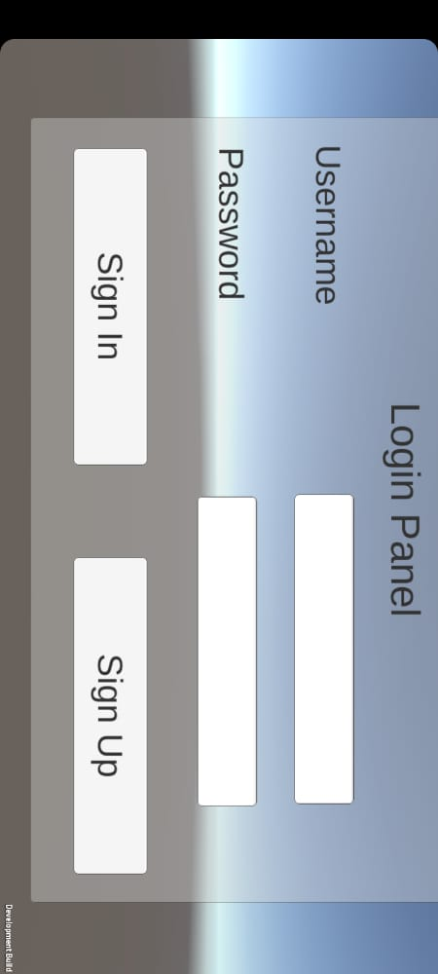

**FIGURE 5.4.1 Login Panel**

### **5.4.2 Splash Screen**

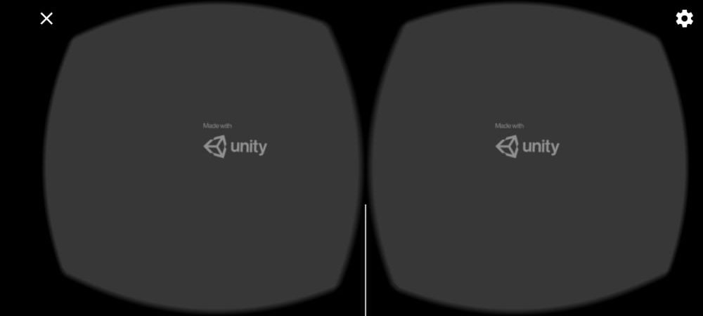

**FIGURE 5.4.2 Splash Screen**

### **5.4.3 Main Menu**

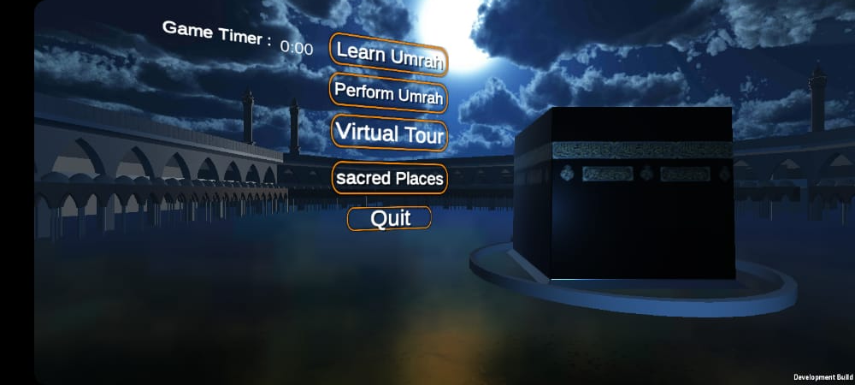

**FIGURE 5.4.3 Main Menu**

### **5.4.4 Ihram steps**

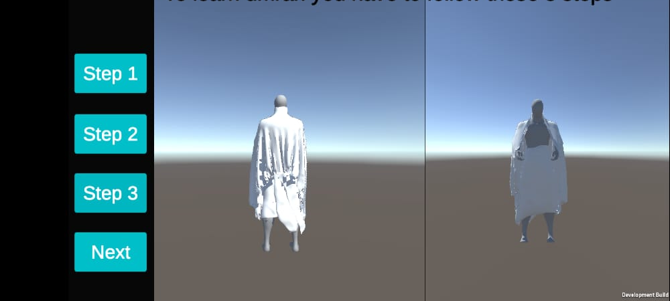

**FIGURE 5.4.4 Ihram Steps**

The first step to perform umrah is to wear Ihram. There are total three steps to wear Ihram. This shot will be displayed only in the learning stage. When all the three steps of wearing Ihram are completed. The user select the next button to move into second step of Umrah.

### **5.4.5 Tawaf e Kaba**

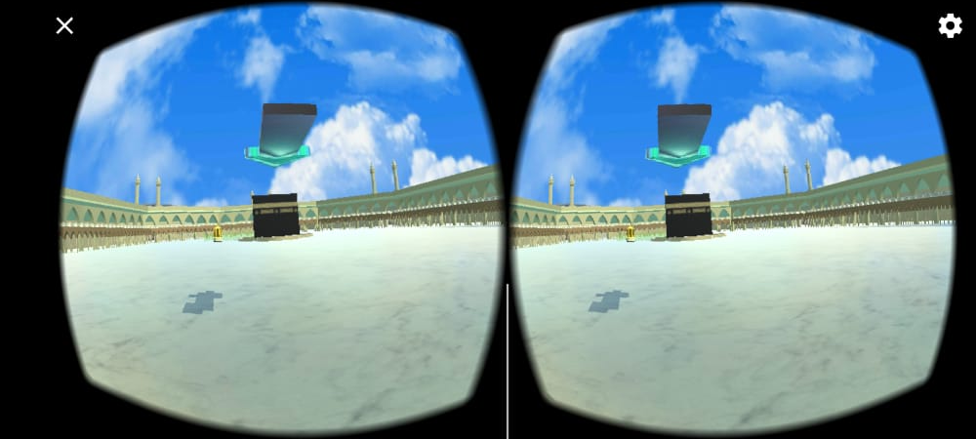

**FIGURE 5.4.5 Learning Module**

The second step after wearning ihram is “Tawaf e kaba”. When the first step is completed, this screen will be appeared in which an arrow indicates towards “khana kaba”. We will go there and start our tawaf.

### **5.4.6 Hajre aswad**

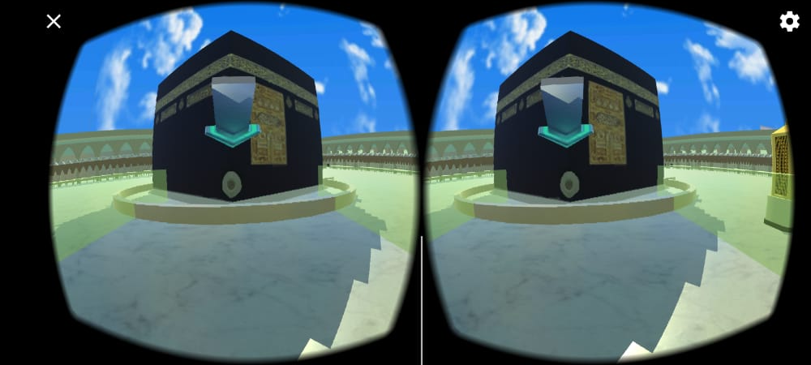

**FIGURE 5.4.6 Hajre Aswad**

The arrow indicates towards “Hajre aswad” from where we will start our tawaf in anticlock wise.

### **5.4.7 Safa o Marwa Hills**

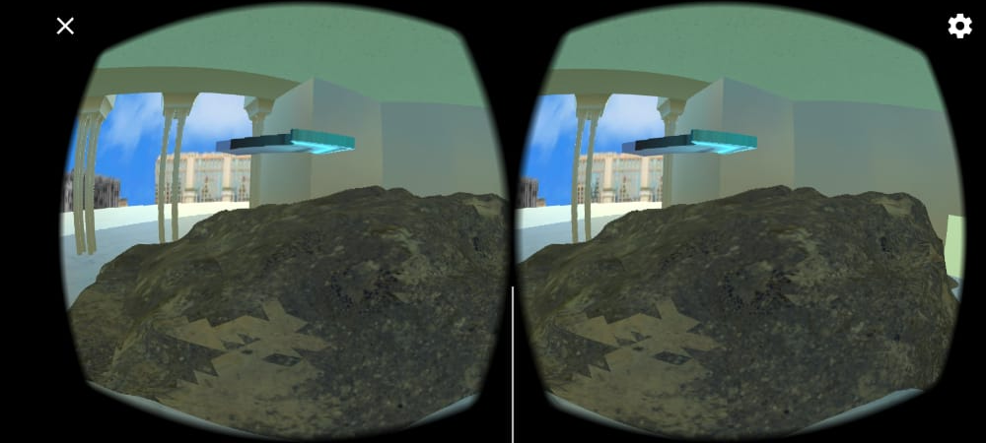

**FIGURE 5.4.7 Safa o Marwa Hills**

### **5.4.8 Safa o Marwa Track**

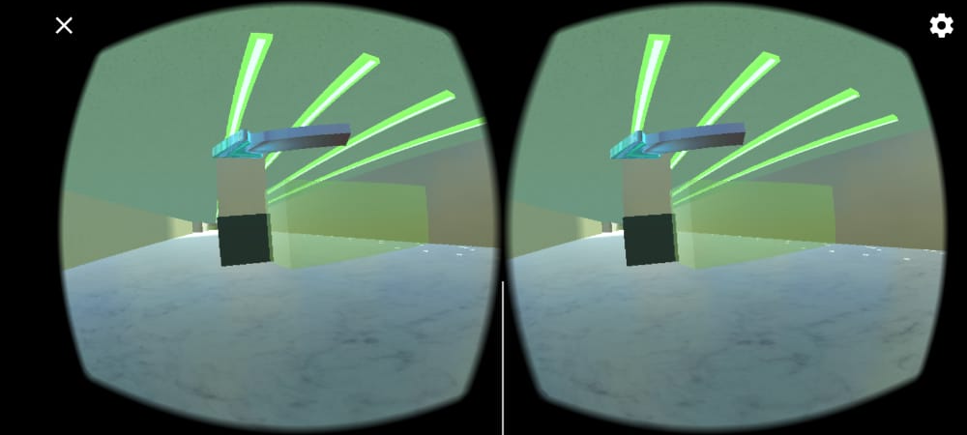

**FIGURE 5.4.8 Safa o Marwa Track**

This is the Safa o marwa track which comes after the completion of “Tawaf e kaba”. We will take our start from safa and ends on marwa by touching this green box. We will complete the seven rounds to complete this task.

### **5.4.9 Sacred Places Information**

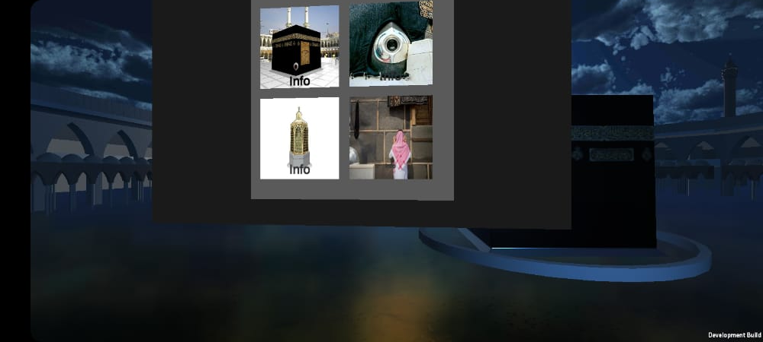

**FIGURE 5.4.9 Sacred Places Information**

# **CHAPTER 6**

# **Evaluation**

## **6.1 Evaluation:**

Our focus was on deep testing of each and every aspect of our Virtual umrah activities. Every functionality is tested and then iterated according to the development methodology.

### **6.1.1 Unit Testing**

Each module of the project was tested, there are multiple modules like player, Environment designing, VR Moments, and Joystick working.

Following test are performed in unit testing:

* Testing Player

1. **Testing Player**

**TEST CASE NO:** 01 **TEST METHOD:** Unit Test

**PROJECT NAME:** Learn Umrah (VR Based) **VERSION:** 01

**TEST CASE DESCRIPTION:** Checking the player Functionalities like Moving, reciting kalimat, sacred places information, Player Score.

|  |  |  |  |
| --- | --- | --- | --- |
| **INPUT NO.** | **FUNCTIONAL INPUTS** | **EXPECTED RESULTS** | **ACTUAL RESULTS** |
| 1 | Start Performing /Visiting/Learning | Player Moves in all Direction | Player Moved |
| 2 | AIM is to Perform Steps Sequentially | Steps Followed Properly | Steps Followed |

**Table 6.1 Testing Player**

**STATUS:** Successful

**CREATED BY:** Jameel Ahmed **CREATED DATE:** March 13, 2021

**EXECUTED BY:** Ahsan Shafiq Khan **EXECUTED DATE:** March 15, 2021

### **6.2.2 Integration Testing**

After testing individual modules, we embedded the modules and started testing the integration phases.Following test are performed in Integration testing:

1. Player Learning Umrah
2. Player Perform Umrah
3. **Player Learning Umrah**

**TEST CASE NO:** 01  **TEST METHOD:** Integration Test

**PROJECT NAME:** Learn Umrah (VR Based) **VERSION:** 01

**TEST CASE DESCRIPTION:** When the Player start learning and Performing the umrah Steps must be follow.

|  |  |  |  |
| --- | --- | --- | --- |
| **INPUT NO.** | **FUNCTIONAL INPUTS** | **EXPECTED RESULTS** | **ACTUAL RESULTS** |
| 1 | Learning Phase | All steps and Description show properly and player follow these steps. | Yes, all steps and Description shown properly and player followed these steps |

**Table 6.2 Player Learning Umrah**

**STATUS:** Successful

**CREATED BY:** Jameel Ahmed **CREATED DATE:** April 03, 2021

**EXECUTED BY:** Ahsan Shafiq Khan **EXECUTED DATE:** April 05, 2021

1. **Player Performing Umrah**

**TEST CASE NO:** 02 **TEST METHOD:** Integration Test

**PROJECT NAME:** Learn Umrah (VR Based) **VERSION:** 02

**TEST CASE DESCRIPTION:** Steps learn in the phase of learning umrah must follow the sequence and perform umrah and scores display.

|  |  |  |  |
| --- | --- | --- | --- |
| **INPUT NO.** | **FUNCTIONAL INPUTS** | **EXPECTED RESULTS** | **ACTUAL RESULTS** |
| 1 | Start Performing | Steps follow properly and score Updated | Steps follow properly and at every wrong step score (must be minus -10) and score Updated. |

**Table 6.3 Player Performing Umrah**

**STATUS:** Successful

**CREATED BY:** Jameel Ahmed **CREATED DATE:** April 06, 2021

**EXECUTED BY:** Ahsan Shafiq khan **EXECUTED DATE:** April 07, 2021

### **6.3.3 Function Testing:**

After integration testing, we tested multiple fundamental game functionalities which are listed below

1. **Update Score**

**TEST CASE NO:** 01 **TEST METHOD:** Function Test

**PROJECT NAME:** Learn Umrah (VR Based) **VERSION:** 01

**TEST CASE DESCRIPTION:** When the player performs the steps in umrah phase, does it update scores or not.

|  |  |  |  |
| --- | --- | --- | --- |
| **INPUT NO.** | **FUNCTIONAL INPUTS** | **EXPECTED RESULTS** | **ACTUAL RESULTS** |
| 1 | Performing Step | Steps Performed Properly | Scores Updated. |

**Table 6.4 Update Score**

**STATUS:** Successful

**CREATED BY:** Jameel Ahmed **CREATED DATE:** April 10, 2021

**EXECUTED BY:** Ahsan Shafiq khan **EXECUTED DATE:** April 13, 2021

1. **User Interface**

**TEST CASE NO:** 02 **TEST METHOD:** Function Test

**PROJECT NAME:** Learn Umrah (VR Based) **VERSION:** 03

**TEST CASE DESCRIPTION:** User interface work properly

|  |  |  |  |
| --- | --- | --- | --- |
| **INPUT NO.** | **FUNCTIONAL INPUTS** | **EXPECTED RESULTS** | **ACTUAL RESULTS** |
| 1 | Start the Application | User Interface interact with user properly. | Yes, User Interface interact with user properly. |

**Table 6.5 User Interface**

**STATUS:** Successful

**CREATED BY:** Jameel Ahmed **CREATED DATE:** April 15, 2021

**EXECUTED BY:** Ahsan Shafiq Khan **EXECUTED DATE:** April 17, 2021

1. **Sound Testing**

**TEST CASE NO:** 03 **TEST METHOD:** Function Test

**PROJECT NAME:** Learn Umrah (VR Based) **VERSION:** 04

**TEST CASE DESCRIPTION:** When the learning and performing face start the Kalimat will also start along with that.

|  |  |  |  |
| --- | --- | --- | --- |
| **INPUT NO.** | **FUNCTIONAL INPUTS** | **EXPECTED RESULTS** | **ACTUAL RESULTS** |
| 1 | Start Umrah | Sounds are working properly | Yes, Sounds are working properly. |

**Table 6.6 Sound Testing**

**STATUS:** Successful

**CREATED BY:** Jameel Ahmed **CREATED DATE:** April 19, 2021

**EXECUTED BY:** Ahsan Shafiq Khan **EXECUTED DATE:** April 21, 2021

# **CHAPTER 7**

# **Conclusion and Future Work**

## **7.1 Conclusions**

The purpose of our app was to give awareness to people of Pakistan about virtual reality. We have tried our best to explain all the important steps and information in detail about our project in the above chapters.

After the complete implementation of app in virtual reality using VR box and joy stick, we have concluded that it has competitive results. First of all we designed the model of “Haram Sharif” and “Safa o Marwa” in the blender. After that we made created some animations in the learning phase for the new users and embedded them into Unity Hub Software.

After completion of coding phase on the models and animations, we come up to testing phase and executed all the phases in a flow.

**Import into IOS:**

We created this app just for the android devices. In future , this app can also be implemented in IOS devices because there are many people who are using IOS devices in today’s era.

**Extension to Hajj:**

As we created the virtual umrah app and we designed the model of “Haram Sharif” and “Safa o Marwa”. This app can be extended to virtual Hajj which will required more models like “Masjid e Nabwi (SAW)”.